SOFTWARE REQUIREMENTS SPECIFIACTION

library management System

Ahmed Sheriff Mohamed 20106620

Omar Mohamed Abo Bakr 20107938

Momen Mohamed Mousa 20107820

Table of Contents

1.INTRODUCTION 2

1.1 PURPOSE 2

1.2 DOCUMENT CONVENTIONS 2

1.3 INTENDED AUDIENCE AND READING SUGGESTIONS 2

1.4 PROJECT SCOPE 2

1.5 REFERENCES 2

2.OverALL DESCREIPTION 3

2.1 PRODUCT PERSPECTIVE 3

2.2 PRODUCT FEATURES 3

2.3 USER CLASS and CHARACTERISTICS 4

2.4 OPERATING ENVIRONMENT 4

2.5 DESIGN and IMPLEMENTATION CONSTRAINTS 4

2.6 ASSUMPTION DEPENDENCIES 5

3.SYSTEM FEATURES 6

3.1 DESCRIPTION and PRIORITY 6

3.2 STIMULUS/RESPONSE SEQUENCE 6

3.3 FUNCTIONAL REQUIREMENTS 6

3.4 CLIENT/SERVER SYSTEM 6

4.EXTERNAL INTERFACE REQUIREMENTS 7

4.1 USER INTERFACES 7

4.2 HARDWARE INTERFACES 7

4.3 SOFTWARE INTERFACES 7

4.4 COMMUNICATION INTERFACES 7

5.NON FUNCTIONAL REQUIREMENTS 8

5.1 PERFORMANCE REQUIREMENTS 8

5.2 SAFETY REQUIREMENTS 8

5.3 SECURITY REQUIREMENTS 8

5.4 SOFTWARE QUALITY ATTRIBUTES 8

# 1.INTRODUCTION

## 1.1 PURPOSE

The main goal of this document is to show the project Library Management system's requirements. The document contains a thorough explanation of the client's functional and non-functional requirements. The purpose of the project is to provide a welcoming environment in which to keep track of information about books and library members. The major goal of this project is to create an easy-to-use computerized circulation system and to generate various reports.

## 1.2 DOCUMENT CONVENTIONS

* Convention for Main title
  + Font face: Calibri Light
  + Font Size: 14
* Convention for Sub title
  + Font face: Calibri Light
  + Font Size: 12
* Convention for body
  + Font face: Calibri Light
  + Font Size: 11

## 1.3 INTENDED AUDIENCE AND READING SUGGESTIONS

This project serves as a proof-of-concept for a library management system. Under the supervision of college professors, this was implemented. Moreover, librarians will benefit from this research in terms of library management.

## 1.4 PROJECT SCOPE

A library management system is a resource planning and enterprise management software that is used to administer and manage the massive amounts of data generated by libraries. It's also used to keep track of invoices, books, and library members who have borrowed books.

## 1.5 REFERENCES

<https://krazytech.com/projects> for SRS document

# 2.OverALL DESCREIPTION

## 2.1 PRODUCT PERSPECTIVE

The library management system is a substitute for traditional library management systems that rely on paper to keep track of books and users.

The library management system will have an advanced book search feature and make borrowing, inserting, and indexing books in the library simple.

## 2.2 PRODUCT FEATURES

The major features of library management system as shown in below ERD model

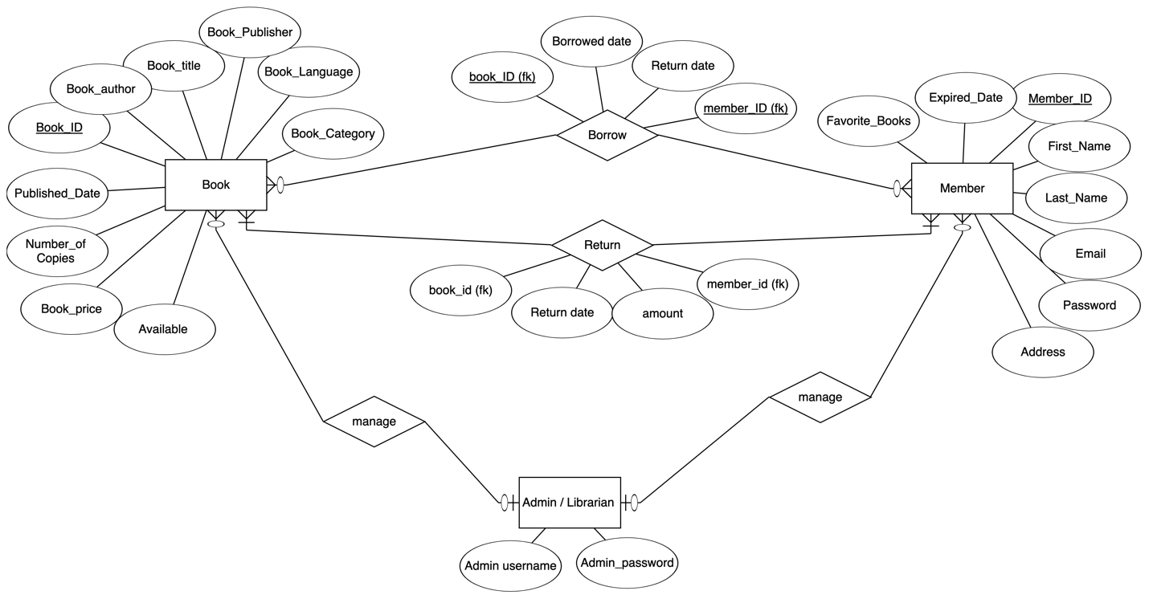

## 2.3 USER CLASS and CHARACTERISTICS

Depending on the kind of user [Member/Librarian], the system offers various services. The Librarian will act as the controller and will have all of the admin privileges. The member might be either a student or a member of the university's staff who will be using the Library system.

###### The Employee should have following management functionalities:

* The Liberian should have following managing functionalities:
* Liberian should be able to insert, modify and delete books.
* Liberian Can add, edit or delete a member
* Liberian Can get the information of any member who has borrowed a book.
* Liberian Can record books returned by users.

###### The member should be able to do the following functions:

* Member can register to the library system
* Members are given a provision to check their account’s information and change it.
* Members have the ability to search through books by subject, title, authors or any information related to the book.
* Member Can borrow books and return them

## 2.4 OPERATING ENVIRONMENT

* database: MySQL
* Front-end: Javafx Application
* Back-end: Java, MySQL
* client/server system

## 2.5 DESIGN and IMPLEMENTATION CONSTRAINTS

* The information of all users, books and libraries must be stored in a database that is accessible by the system.
* MySQL Server will be used as MySQL engine and database.
* Users may access the system from any computer from the library.
* Users must have their correct usernames and passwords to enter into their accounts and do actions.

## 2.6 ASSUMPTION DEPENDENCIES

##### The assumptions are :-

* The coding should be error free
* The system should be user-friendly so that it is easy to use for the members ¬
* The information of all users, books and libraries must be stored in a database that is accessible by the system
* The system should have more storage capacity and provide fast access to the database ¬
* The system should provide search facility
* Users must have their correct usernames and passwords to enter into their accounts and do actions

##### The dependencies are:-

* The specific hardware and software due to which the product will be run
* On the basis of listing requirements and specification the project will be developed and run
* The end users (Librarian, members) should have proper understanding of the product
* The information of all the users must be stored in a database that is accessible by the Library System
* Any update regarding the book from the library is to be recorded to the database and the data entered should be correct

# **3.System features**

## **3.1 DESCRIPTION and PRIORITY**

The Library Management System keeps track of the library's books and users. Of course, this project is a high priority since storing the massive amounts of data created by libraries is extremely difficult.

## 3.2 stimulus/response sequence

* Management for Books and Members
* Search for Books and Members
* Display for Available books in Database

## 3.3 functional requirements

##### Liberian:

* Add, Edit , View, Search and Delete Book
* Add ,Edit , View ,Search and Delete Member
* Return borrowed books form members

##### Member:

* View, Search Books
* View , Edit his/her information
* Borrow book
* Return book
* Chat System

## 3.4 CLIENT/SERVER SYSTEM

The term client/server refers primarily to an architecture or logical division of responsibilities, the client is the application (also known as the front-end), and the server is the DBMS (also known as the back-end).

A client/server system is a distributed system in which the client(Member) can chat with server.

# 4.EXTERNAL INTERFACE REQUIREMENTS

## 4.1 USER INTERFACES

* Front-end software: Javafx
* Back-end software: Java, MySQL

## 4.2 Hardware interfaces

* OS (Windows , MAC OS)

## 4.3 SOFTWARE INTERFACES

Following are the software used for the Library Management System application.

|  |  |
| --- | --- |
| Software Used | Description |
| Operating System | We picked Window and Mac OS because of its excellent support and user-friendliness. |
| Database | We used MySQL database to store our system data |
| Javafx | We used Javafx for our User interface |
| Java , MySQL | To implement the project, we have chosen Java language for its more interactive support and MySQL for connecting and communicating with our database |
| MySQL Workbench | To manage our database, we used mysql workbench for our database management system |
| IntelliJ IDEA | To write our code we used IntelliJ IDEA System for its great support for Java and Javafx |

## 4.4 COMMUNICATION INTERFACES

This project supports all types of OS .We are using simple electronic forms for the Managing Books and Members in our Database

# 5.NON FUNCTIONAL REQUIREMENTS

## 5.1 PERFORMANCE REQUIREMENTS

The suggested system would be employed as a performance system in various libraries, interacting with librarians and library members. As a result, it is predicted that the database will meet all of the Library's needs in terms of functionality.

* The performance of the system should be fast and accurate
* The Library Management System must manage both expected and unexpected problems in a way that prevents data loss and prolonged downtime. As a result, it should contain built-in error checking to detect incorrect usernames and passwords.
* The system must be capable of processing enormous amounts of data. As a result, it should be able to handle a large number of books and users without issue.

## 5.2 SAFETY REQUIREMENTS

The database might crash at any time owing to a virus or a malfunction of the operating system. As a result, a database backup is essential to ensure that the database is not lost. In the event of a power outage, a suitable inverter should be available.

## 5.3 SECURITY REQUIREMENTS

* System will use secured database
* Normal users can just read information but they cannot edit or modify anything except their personal and some other information.
* Proper user authentication should be provided
* No one should be able to hack users’ password
* There should be separate accounts for librarians and members such that no member can access the database and only librarians has the rights to update the database.

## 5.4 SOFTWARE QUALITY ATTRIBUTES

* **Scalability : The system is quick and accurate in its output.**
* **Usability: the system has a friendly interface for members and Librarians**
* Maintainability: The database's quality is maintained in such a way that all database users will find it highly user pleasant.
* Availability : The system will be simple to download and install, and it will be available at any time.